Week 6 - S6 - Core OOP - Inheritance - Lab Problem

Name:Ramesh Harisabapathi Chettiar

Date of Submission:23/09/25

Qno1🡪Problem Statement:

Create a Fruit class with color and taste fields. Create an Apple class that extends

Fruit and adds variety field.

Hints:

● Use extends keyword for inheritance

● Make fields protected in parent class

● Test by creating Apple object and accessing inherited fields

**PROGRAM🡪**

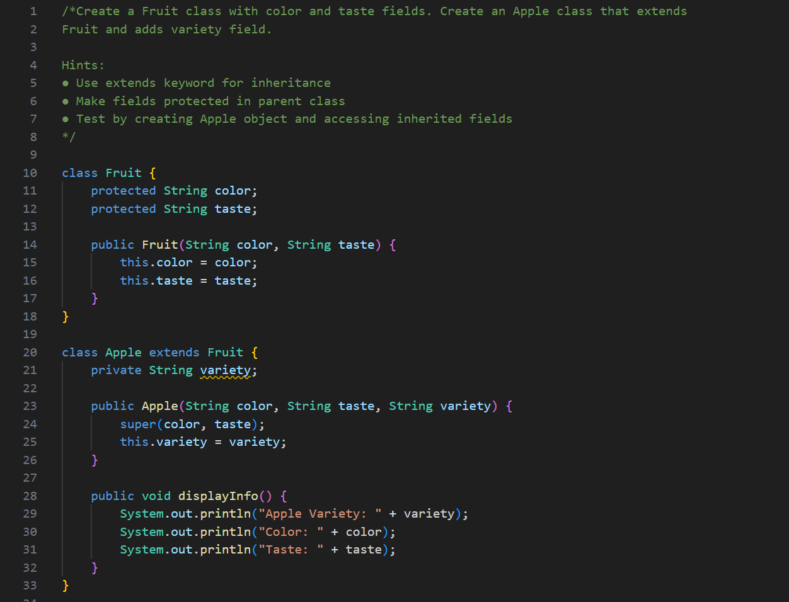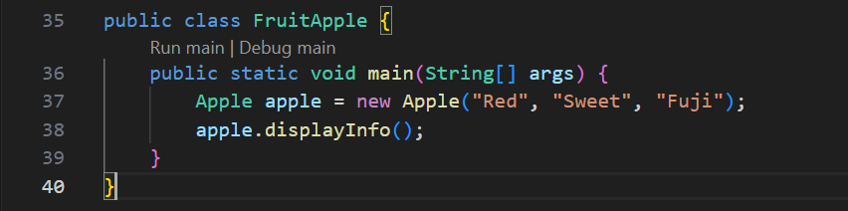

**OUTPUT🡪**



**QNO2🡪Problem Statement:**

**Create Phone class with brand and model. Create SmartPhone class extending Phone with**

**operatingSystem field. Use constructor chaining.**

**Hints:**

**● Add print statements in constructors to see execution order**

**● Use super() in child constructor**

**● Create objects using different constructor combinations**

**PROGRAM🡪**

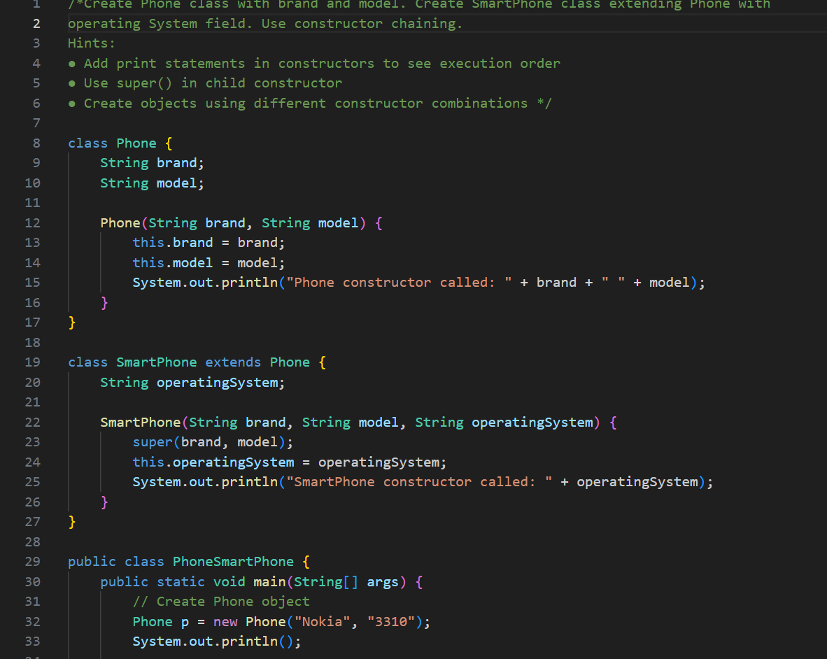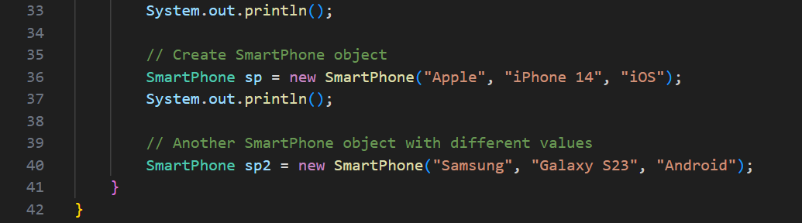

**OUTPUT🡪**

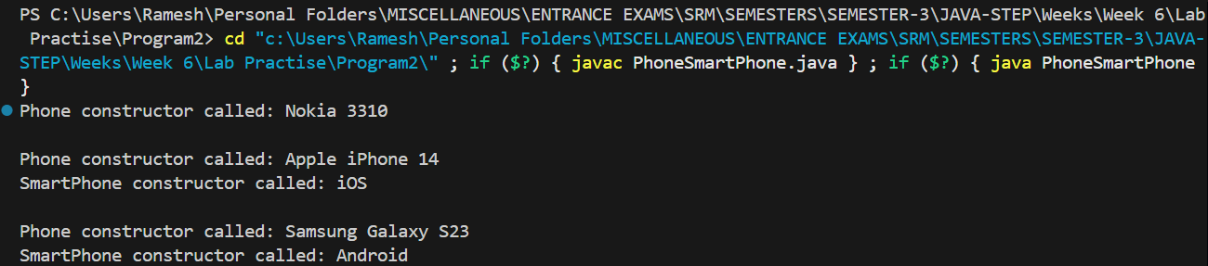

**QNO3🡪**

**Problem Statement:**

**Create Bird class with fly() method. Create Penguin and Eagle classes that override**

**fly() method differently.**

**Hints:**

**● Use @Override annotation**

**● Make different implementations in each child class**

**● Test polymorphism with array of Bird references**

**PROGRAM🡪**

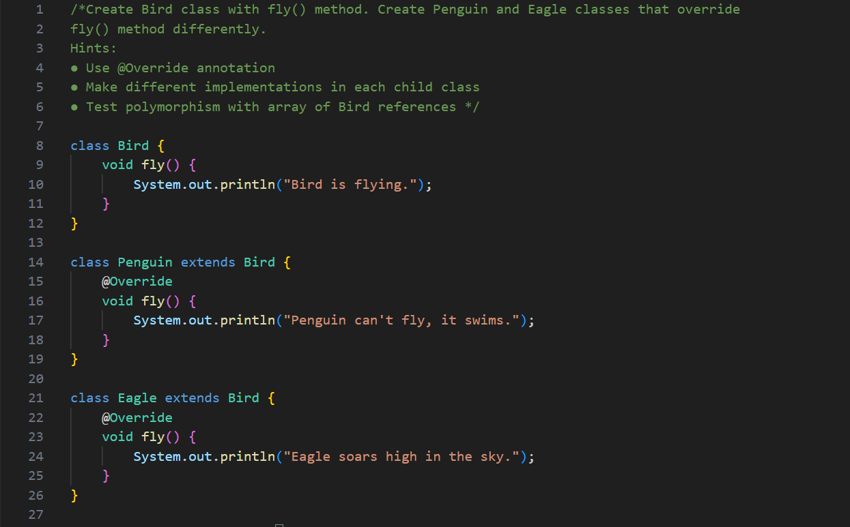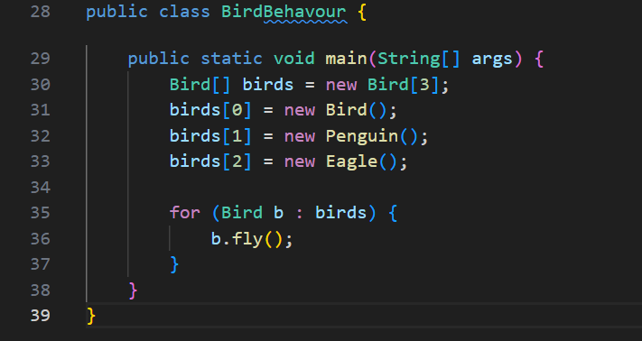

**OUTPUT🡪**

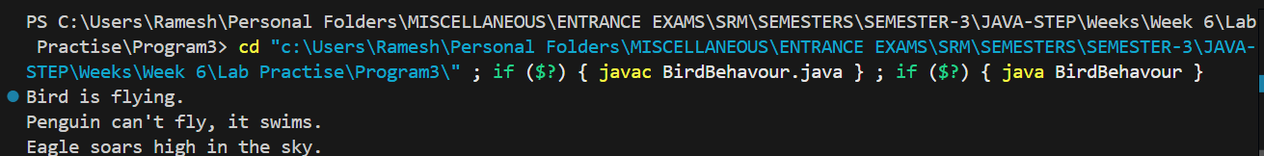

**QNO 4🡪**

**Problem Statement:**

**Create inheritance chain: Color → PrimaryColor → RedColor. Each class adds specific**

**properties and methods.**

**Hints:**

**● Color has name field**

**● PrimaryColor adds intensity field**

**● RedColor adds shade field**

**● Show constructor chaining through all levels**

**PROGRAM🡪**

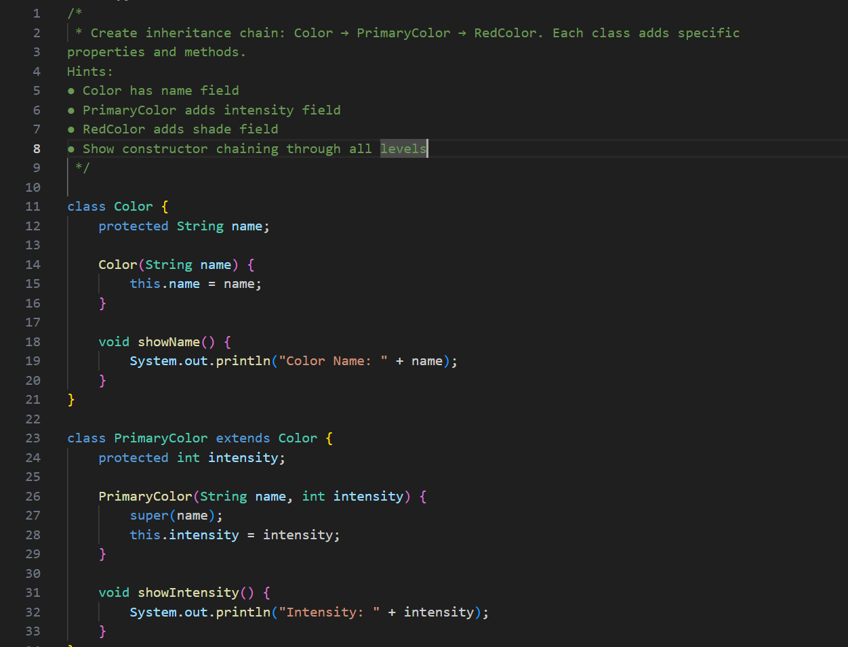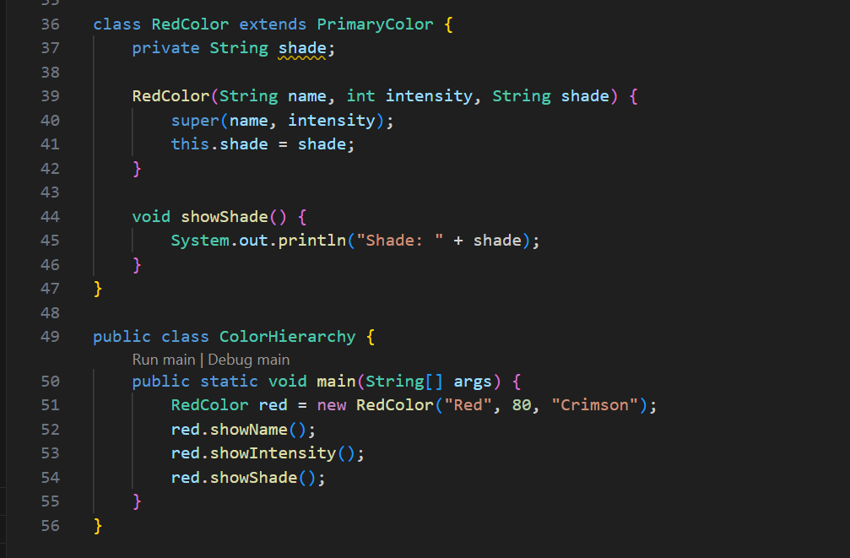

**OUTPUT🡪**

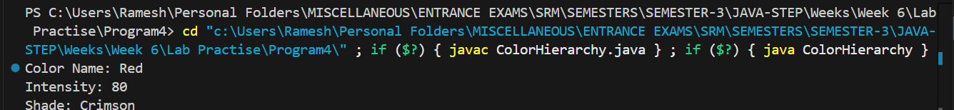

**QNO 5🡪**

**Problem Statement:**

**Create Instrument base class. Create Piano, Guitar, and Drum classes that all extend**

**Instrument.**

**Hints:**

**● Base class has common fields like name, material**

**● Each child adds specific fields (strings, keys, etc.)**

**● Test using array of Instrument references**

**PROGRAM🡪**

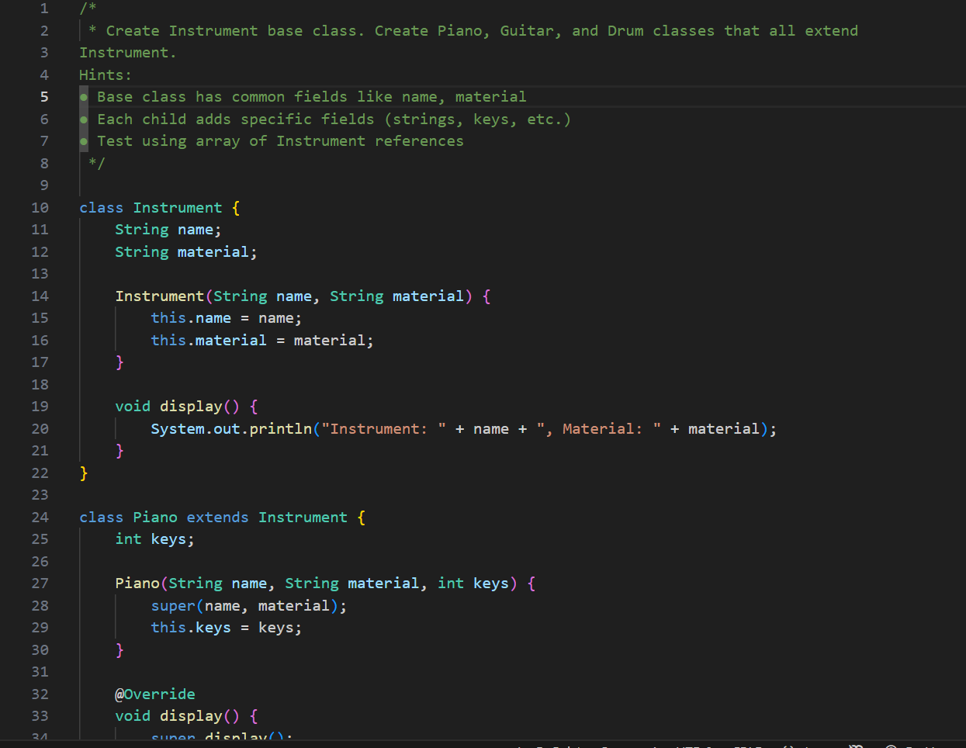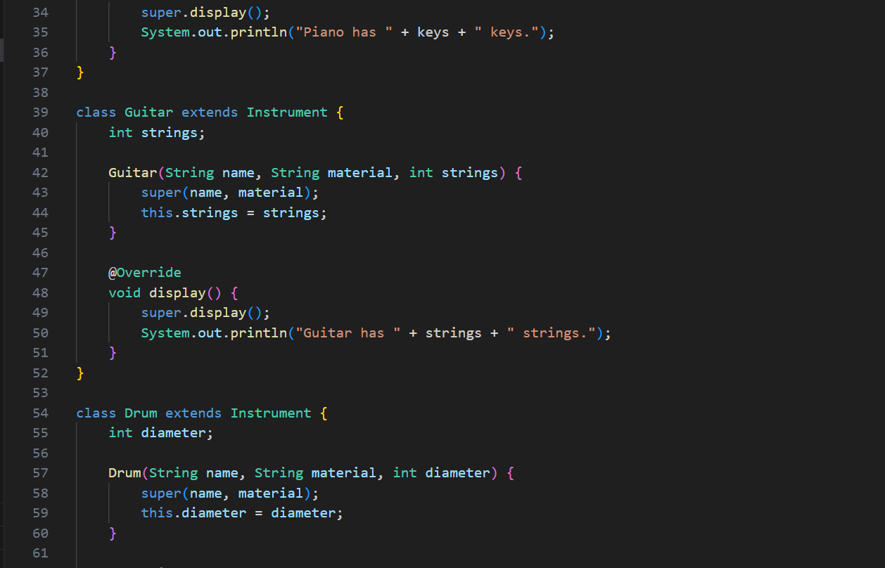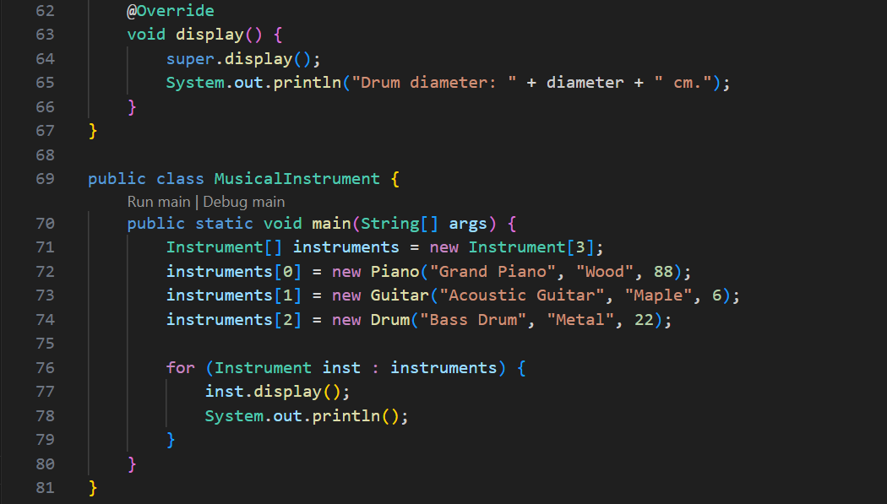

**OUTPUT🡪**

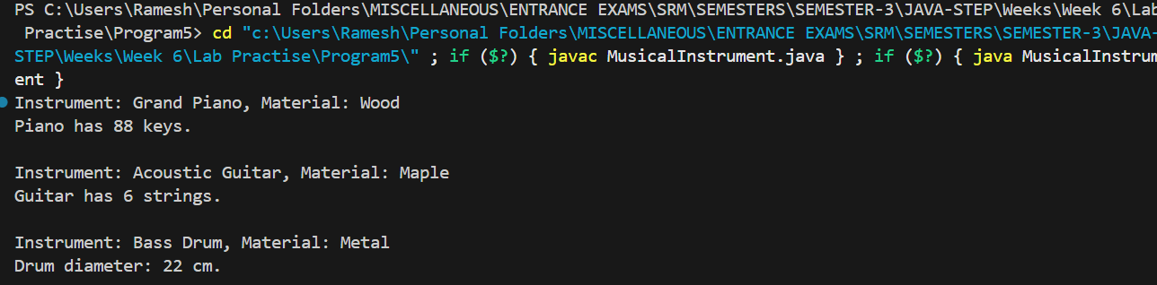

**QNO 6🡪**

**Problem Statement:**

**Create Box class with pack() and unpack() methods. Create GiftBox that overrides these**

**methods but still uses parent functionality.**

**Hints:**

**● Call super.pack() in overridden method first**

**● Add gift-specific functionality after super call**

**● Show enhanced behavior while preserving original**

**PROGRAM🡪**

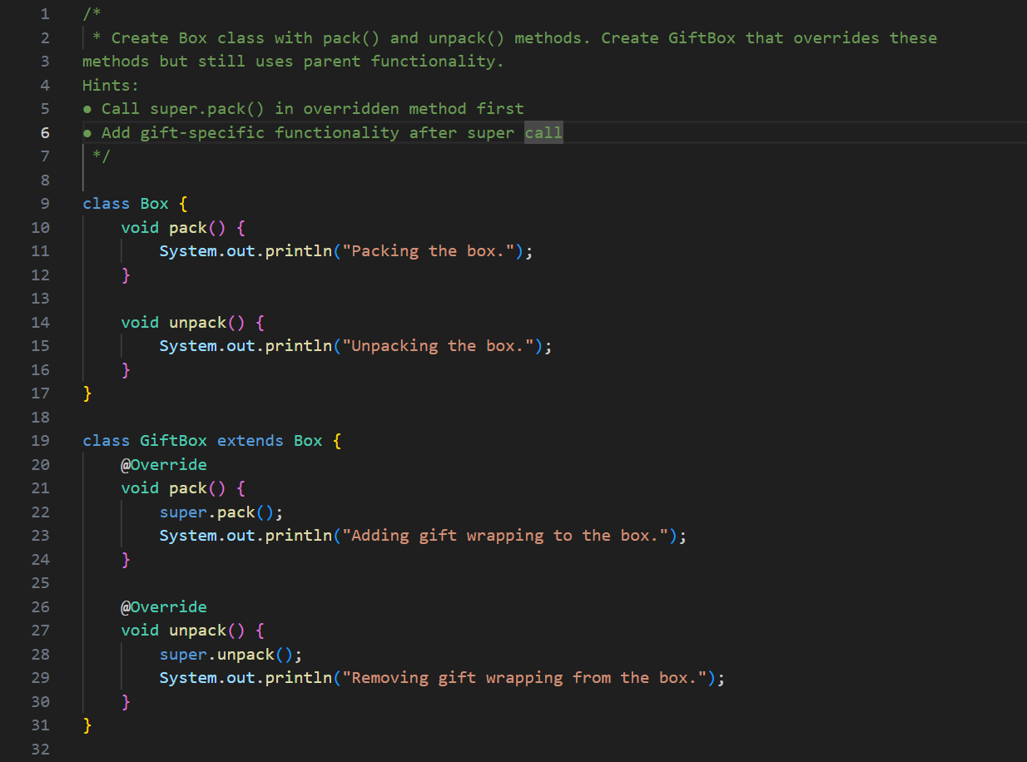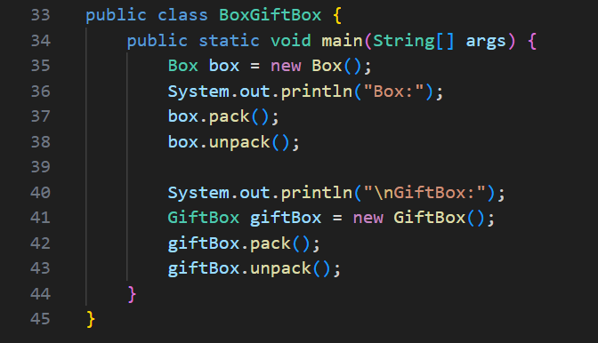

**OUTPUT🡪**

